TOONY WARS

Toony wars is a game that has two towers one each side. The purpose of this game is to win by destroying the other side’s tower.

The player summons troops. Each troop has different weapons to destroy the towers and other enemies. The program keeps track of the towers life and the troop’s life. It animates how the troops walk and shoot there weapon.

There are 3 different kind of troops.

|  |  |  |
| --- | --- | --- |
| Types of troops | Weapons | picture |
| melee | sword |  |
| Bazooka Man | Big bomb, bazooka |  |
| Gun man | Lasers |  |

Main menu

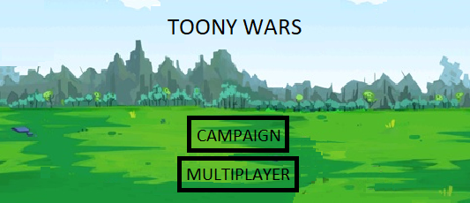

When the program starts, a player has an option to select campaign mode or multiplayer using the mouse to click on the button. Then using the keyboard keys (1,2,3) to summons the different kinds of troops. The player has to destroy the tower to win.

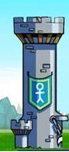

Variables for towers:

* Life – integer value of hp
* visible – True or False (set to True in the beginning until life = 0 then its false)
* towerX – horizontal position
* towerY – vertical position

Variables for each troops:

* life – integer value of hp
* weapons – use to deduct life from enemies and towers, when collide(using distance formula)
  + melee - deduct enemy’s life when contact
  + bazooka - fire out from the enemy, it can deduct enemy’s life when its being contacted
  + guns – fire out from the enemy really fast, it can deduct multiple enemy’s life when its being contacted
* visible – True or False (set to True in the beginning until life = 0 then its false)
* troopX – Troop vertical position
* troopY – Troop horizontal position
* speedX – troop movement direction(troops only move horizontally)
* damage – Ability to deduct life from enemies

Variables for each weapons:

* damage – Ability to deduct life from enemies
* speedX – weapon horizontal movement
* speedY – weapon vertical movement
* weaponX – horizontal position of weapon
* weaponY – vertical position of weapon
* rangeX – the maximum horizontal distance it can travel
* visible – True or False (set to True when fired = when it hits or off the range)

Each player has a tower and a collection of troops and each troop has a collection of weapons